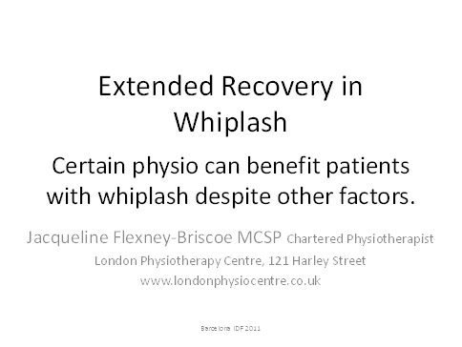

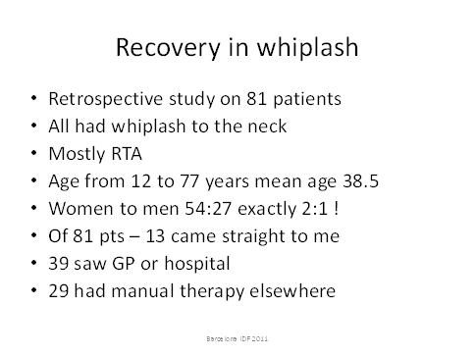

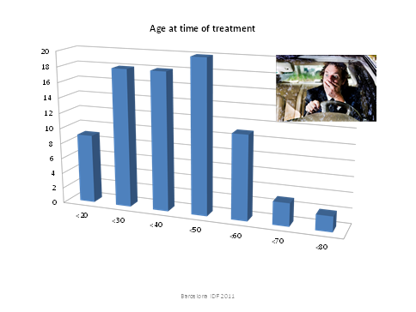

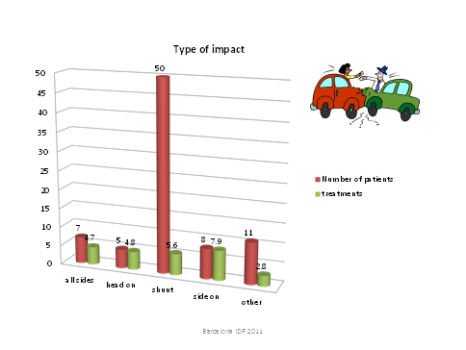

Machine generated alternative text: Time between accident and Rx
18 ——---
1--
14
12
lo
8
6
4
2
o
,,, , , , ,
• Patients
• Treatments
Barcelona IDF 2011

Machine generated alternative text: Symptoms at start of treatment
No previous treatment n=13
10
7 __________________________ • taking pain kil nrc
• duturbed seep
1 ________________________ • cough eue
• hnadaehn
5 _______________ 5 •urrrrp
. pOrt
. msusun mouemerrt slight
3 moderate
1 1
o o
Barcelona IDE 2011

Machine generated alternative text: Symptom change
No previous treatment n=13
Barcelona IDF 2011
14.0
62.0
10.0
6.0
4.0
2.0
0.0
• start
end
----
pain
headache
limitation
movement

Machine generated alternative text: 25
Symptoms at start of treatment
Medical help before treatment n=39
25
• pan at start
• taking pain kil nro
• d nturbnd n nnp
• cough nue
• hnadanhn
. 5&n
m nan on mnnnmnnn slight
::::°
25
no Sn Sn
gp
55
Æ -
—
I
I
il
I
‚‚o’
I
Barcelona DF 2011

Machine generated alternative text: Symptom change
Medical help before treatment n=39
limitation movement
Barcelona lOF 2011
• start
D end
40.0
30.0
25.0
20.0
35.0
no.0
5.0
0.0
pain
headache

Machine generated alternative text: n pain at start
n taking pain killers
n disturbed sleep
n cough -uve
n headache
n p&e
limitation m000meot slight
n moderate
Symptoms at start of treatment
Other manual therapy before treatment n=29
25.0
20.0
15.0
10.0
5.0
0.0

Machine generated alternative text: Symptom change
Other manual therapy before treatment n=29
20.0
18.0
16.0
14.0
12.0
10.0
.
pen D
Barcelona IDF 2011
limitation
movement

Machine generated alternative text: 6.0
5.0
4.0
3.0
2.0
1.0
0.0
Barcelona IDF 2011
Average number of
physiotherapy treatments
medical advice
manual therapy

Machine generated alternative text: lo
Pain levels at start and finish of treatment
pain at start average patat end —number of pat ests
Barcelona IDF 2011

Machine generated alternative text: So what do I do that’s different?
• Minimal intervention!!!
• Improve drainage
using very gentle manual lymphatic drainage
massage
• Increase circulation to the neck — gently!
using connective tissue manipulation (CTM)
. Reduce soft tissue tension
with CTM
. Reduce pain as a result of the above.
Barcelona IDF 2011

Machine generated alternative text: What is Connective Tissue
Manipulation? (CTM)
• CTM ¡s a German technique that uses the
finger tip to gently move two layers of skin
• For whiplash moving the dermis on the fascia
. Creates a stretch reflex
. Patient feels sharp cut
. Reflex reduces connective tissue tension
. Increases blood flow
. lmprovesrangeofmovement
Barcelona IDF 2011

Machine generated alternative text: • Insurance Claim
No insurance claim
Patient perceived improvement / insurance claim
16
14
12
10
50% 60% 70% 80% 85% 90% 95% 100%
Barcelona lOF 2011

Machine generated alternative text: Conclusion
• Despite
• Time elapsed since the accident
• Type of accident
• Age of patient
• Prior interventions
• MLD and CTM can treat whiplash effectively
• And other conditions as well!
Barcelona IDF 2011